Longleaf Pine
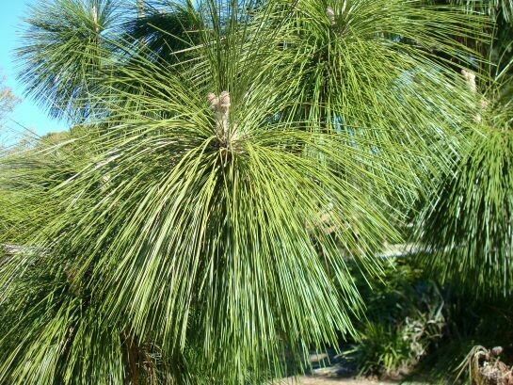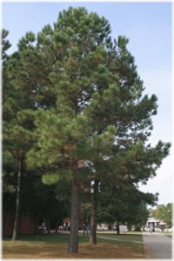

Two 7-gallon Longleaf pine trees were planted at VISTA Gardens on December 18, 2021, by VISTA gardener, Doug Kostelnik, and volunteers from Sickles High School National Honor Society.
Longleaf Pine, Pinus palustris, reaches 80-100 ft. with a dense and majestic crown as the tree ages. Longleaf Pine is a leading world producer of naval stores and has historically been a tremendous economic resource for turpentine, lumber, sail masts, and more. This species has been over depleted in the wild and under planted in tree replacements. This was once the dominant pine species throughout the Southeast and should be the first choice in pine plantings for drained environments and it has coastal adaptation. This ecologically important species is the most magnificent, stately, durable, and long lived (300 to 500 years old) member of the pine tree group in Florida. Longleaf Pine is a historical backbone in Southeastern U.S. ecology, including Florida.
https://www.wilcoxnursery.com/store/Longleaf-Pine-p189370687

