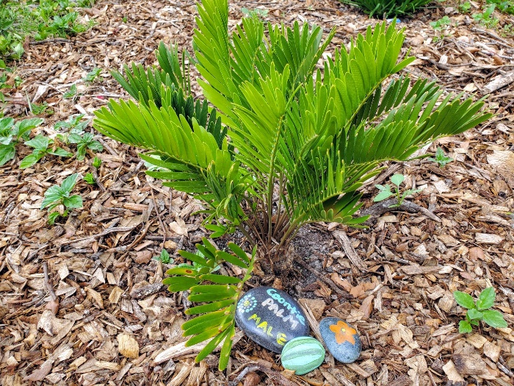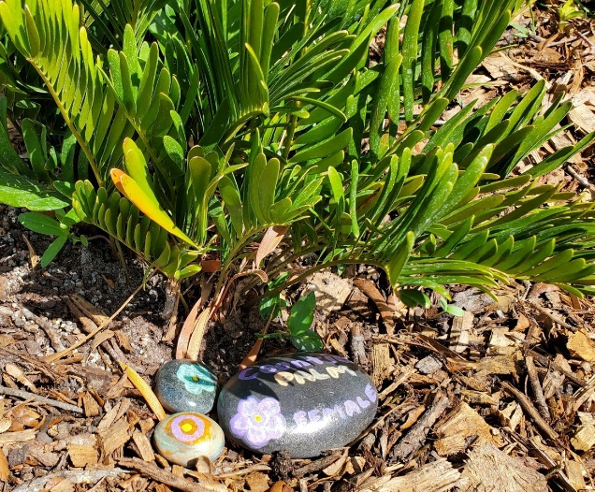
Coontie Palm
Zamia integrifolia

Coontie, a member of the prehistoric cycad plant family, is a shrub with a buried woody stem that is almost completely underground and produces a terminal crown of semi-stiff, evergreen, pinnate leaves 2 to 3 ft. long. The brown, fleshy, female seed-bearing cones, 6-8 in. long, are pendent when mature and covered with dark-brown hairs.
Coontie lends it beauty to natural or formal landscape settings. It is easy to grow in full shade to full sun in well drained to dry soils. This plant is highly salt tolerant, but not tolerant of wet or heavy soils.
Be sure to give this slower growing plant room for its mature size, since it is not a plant that should be pruned.
https://www.wilcoxnursery.com/store/Coontie-p181328578
Larval host for atala butterfly (Eumaeus atala florida) and the echo moth (Sierarctia echo). Long-lived perennial.
https://www.fnps.org/plant/zamia-integrifolia

