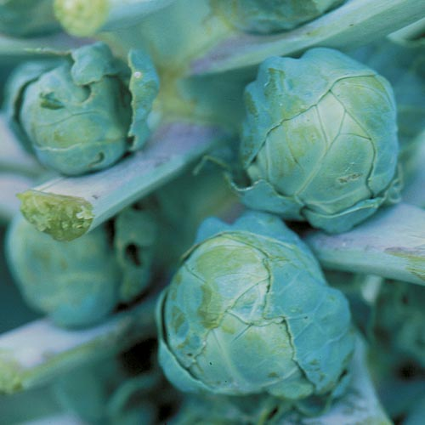

**Brussels sprouts, Long Island Improved**

**Tall 30-36"plants yield 50-100 dark green 1½ inch sprouts over an extended period. Transplant in late fall, as they require cool temperatures to develop firm, crunchy sprouts. Warm weather causes individual sprouts to be soft and open rather than solid and tightly packed.** [**http://edis.ifas.ufl.edu/mv034**](http://edis.ifas.ufl.edu/mv034)

**Culture: Moist fertile soil. Mix in balanced organic fertilizer when transplanting. Ideal average temperature is 58–60°F.**

**Spacing: 24 inches. Support plants, as upright Brussels sprouts plants produce better than crooked ones. Plants reach a height of 30-36 inches.**

**Irrigation: Keep plants watered regularly and the soil moist. 1-1 ½ inches of water weekly is recommended.**

**Fertilization: Brussels sprouts are heavy feeders. Fertilize when transplanting, when 12" high, and every three to four weeks thereafter. Do not disturb soil directly around plant as roots are shallow and susceptible to damage.**

Growing Tip: Removing the terminal growth tip when the plants are 15–20 in. tall makes the sprouts grow larger and mature more quickly.

**Maturity: 80-115 days from transplant. Begin harvesting sprouts when the sprouts are firm and are approximately 1 inch in diameter. Mature sprouts will develop near the bottom of the plant first. Use a sharp knife to harvest individual sprouts as they mature.**

**Pick the sprouts as needed, but usually at about 2-week intervals. Continue harvesting as long as good sprouts are formed. Just like broccoli and cauliflower, the leaves are often discarded in favor of the other parts of the plants, but these hearty, leafy greens are excellent sliced and sautéed instead of kale or collards. The stalk is edible and much tastier with outer layer removed.**

**Fresh Brussels sprouts will keep for several weeks in the refrigerator. If you’d like to stretch your enjoyment of Brussels sprouts into the winter, this vegetable can be blanched and frozen.**

*“Very productive once they get going. they grow very slowly, but the taste is worth the wait. Also, they are fun to grow with kids since they grow so different than most of the plants they see out and about.”* Review posted by Seed Savers Exchange

[**https://www.seedsavers.org/long-island-brussels-sprouts**](https://www.seedsavers.org/long-island-brussels-sprouts)

**Brussel sprouts are compatible with beets, carrots, celery, leeks, lettuce, nasturtiums, onion, and pea.**

**Brussel sprouts are incompatible with pole beans, kohlrabi, strawberries, and tomatoes*.**

**\*Brassica crops contain plant chemicals that inhibit tomato growth, as well as other nightshades like eggplants and peppers.**