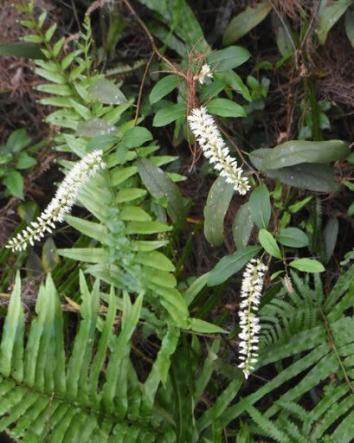

**Virginia Sweetspire**

***Itea Virginica***

**Also known as Henry’s Garnet, this compact shrub is commonly found in swamps, stream banks, wet hammocks, and floodplain forests throughout Florida.**

**A great addition to any garden landscape, it features graceful arching branches that grow 3-4 feet tall and 4-6 feet wide. Blooms in mid-spring with tiny, fragrant white flowers along drooping flower spikes 3 to 6 inches long. Very showy!**

**The plant’s stem also adds color to the landscape, starting out purplish-red and changing through shades of red, brown and green as it matures.**

**Provides four seasons of beauty! The bottlebrush shaped flowers are loved by bees and butterflies.**

[**https://www.wilcoxnursery.com/?s=Virginia+Sweetspire**](https://www.wilcoxnursery.com/?s=Virginia+Sweetspire)