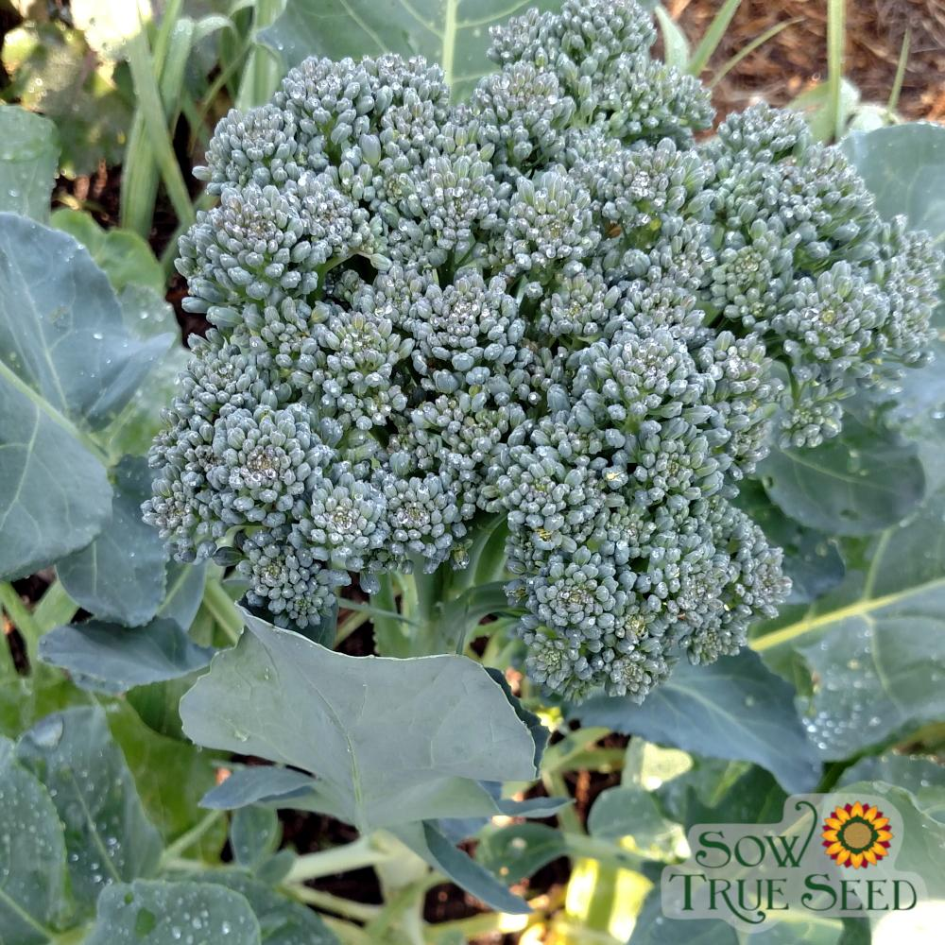
Di Cicco Broccoli, Organic

Heirloom vigorous, light-green plant produces a 3-4" bluish-green central head. After the central head is cut, many medium-sized side shoots take its place for a prolonged harvest. Rich in vitamins A, C, and K, as well as potassium, phosphorus, and iron.

Culture: Best grown in temperatures between 45-75 degrees. Tolerates much lower temps. Prefers a well-drained, fertile soil high in organic matter with a pH of 6.0–6.8.

Spacing: Transplant seedlings 18 inches apart. Firm soil around transplant to be sure there are no air pockets!
If direct sowing seeds, plant ¼ inch deep in groups of six every 18 inches. When sprouts are 2 inches tall, thin out five, leaving 1 seedling to grow every 18 inches. Water soil regularly so it stays evenly moist until the seeds germinate in seven to 14 days.

Irrigation: Broccoli needs 1 to 2 inches of water weekly. Water the ground under the plants and not the broccoli itself to make it less susceptible to soil-borne diseases. Cut back on watering when plant reaches maturity.

Fertilizer: Use a balanced fertilizer at the time of planting and repeat three applications: 1) when plant grows to 6-8 inches in height, 2) when plant is 12-15 inches tall, and 3) when the buds first form. Broccoli also benefits from supplemental calcium in the soil. (If your fertilizer does not contain calcium, you can mix ground oyster shell or dried, crushed eggshells and into the soil at the time of planting).

Matures 45-85 days to height of 24-36 inches. Harvest the main head while it is still tight, and before florets begin to turn yellow; cut at least 6 inches of the stem. Side shoots will continue to develop along the stem and can be harvested as well; the plant will keep producing as long as weather conditions are favorable.
https://sowtrueseed.com/products/broccoli-di-ciccio-organic
Extra Growing Tips:
The trick to producing good broccoli is to keep it growing steadily. Two to three weeks after transplanting, top dress with compost tea or side-dress with blood meal or fish emulsion, and water deeply. Repeat monthly until a week before harvesting the flower head. This regimen also encourages large and tender side shoots, which you can harvest until hot weather.
Cultivate around young plants to get rid of weeds and keep the soil loose. If daytime temperatures exceed 75°F, put down a thick layer of organic mulch to cool the soil and conserve moisture. Broccoli needs steady 1 - 1½ inches of water a week (slightly less during fall months.) A lack of water will result in tough stems.
Compatible plants include carrot, celery, cucumber, lettuce, radish, shallot, spinach, and Swiss chard. Because broccoli is a notorious calcium-hog, plants that require little calcium (e.g. beets, nasturtiums, marigolds) are good companion plants.

Incompatible plants include peppers, mustard greens, pole beans, lima beans, snap beans, squash, and strawberries. Since broccoli is a heavy feeder, other heavy-feeding plants are not good companions (cantaloupe, pumpkin, sweet corn, and watermelon).

