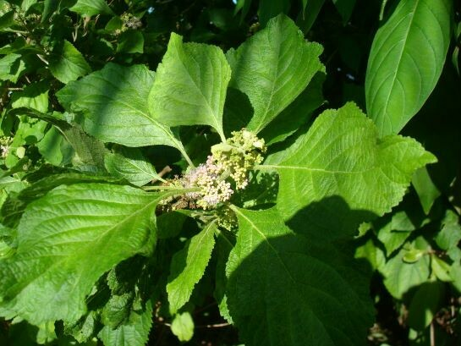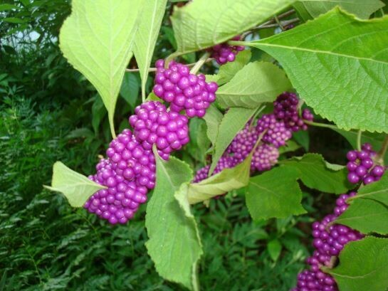

American Beautyberry
Callicarpa americana
Shrub that grows to 6 to 12 ft. tall and about as wide. Long, arching branches display small pink flowers in the spring and early summer as well as the highly decorative purple berries clustered down the outer parts of their stems in late summer and fall. There is a far less common white berry form. The leaves are a soft median green. Pollinators are attracted to the subtle, but attractive small flowers and songbirds to the showy berries.
Beautyberry is a very easy growing, drought tolerant shrub for well-drained soil and partial shade to full sun. The plant is denser in sun and more openly branched in shady settings. It is naturally distributed throughout Florida. Beautyberry is cold hardy and is winter dormant.
https://www.wilcoxnursery.com/store/Beautyberry-p181120299
Works for foundation, border, or mass planting. Can also be grown in container or aboveground planter. If not completely devoured by birds the shiny berries will persist on the stems for several weeks after the leaves drop.
https://edis.ifas.ufl.edu/fp090

