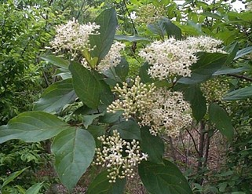

**Swamp Dogwood**

***Cronus Foemina***

**Swamp dogwood is found only in low, moist woodlands and swamps throughout the southeastern U.S. and west to Missouri. It grows 10 to 15 feet tall and wide with stiff, upright branches, reddish-purple stems, and dark green leaves that are 1 to 4 inches long.  In Spring you will find creamy white flowers in clusters up to 3 inches across.  In the fall the fruit turns blue and is about 1/4 inch in diameter.  Typical of most dogwood plants, this shrub is deciduous and drops its leaves in the fall.**

**Swamp Dogwood is a valuable choice for naturalized or planting in shrub borders in both moist or soggy sites.**

[**https://www.wilcoxnursery.com/?s=Swamp+Dogwood**](https://www.wilcoxnursery.com/?s=Swamp+Dogwood)